# IT file - **AVPN_SOC_20180301_MASTERRates_v_1_00_20180708.xlsx**

<https://tspace.web.att.com/communities/service/html/communityview?communityUuid=47e067fd-e3e8-47a2-8fa1-94e89d68b60d#fullpageWidgetId=W4082a0e50777_4a3d_b032_519b22d64d4e&file=a453fb30-df4f-4e8d-a29c-f3eefa74622b>

# Product Requirement

<https://tspace.web.att.com/communities/service/html/communityview?communityUuid=47e067fd-e3e8-47a2-8fa1-94e89d68b60d#fullpageWidgetId=W4082a0e50777_4a3d_b032_519b22d64d4e&file=17b50d95-01ab-4ab7-aa28-1d92d5aae6a0>

# SOC Tool export data files to be compared

Country Details Table



There is a data issue in Country Details export file. Georgia should be GE. I have manually updated it to GE before comparison.

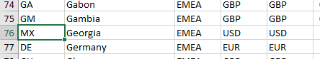

SOC Discount Table



BEID Master Table



# Issues in the Top Section from Row 1 to 11

Compare result



1. Some Template Layout numbers look strange. They have very large number or even decimal.
2. Future&Current PDF Flags show different value although they seem having same meaning. IT File shows “No”, Tool Export Data shows “FALSE”)
3. Country name mismatch. Saint Helen in SOC Tool Country Details export data, Saint Helen, Ascension and Tristan da Cunha in IT file.
4. Region mismatch although IT file seems having correct data. In other words, SOC Tool is having incorrect data. Does it imply IT file is not getting data from SOC Tool Country Detail? Where do the IT file get data from?
5. Template Layout numbers are missing for some countries
   1. Future Col 103 GF, Col 110. GL, Col 168 FM, Col 183 NC, Col 228 SS
   2. Current Col 39 AQ, Col 89 DG, Col 115 GG, Col 130 IM, Col 136 JE, Col 162 MH, Col 192 PW, Col 206 SH, Col 226 SO, Col 231 SD, Col 236 SY, Col 250 UM, Col 258 VA
6. For those countries with 2 currencies, they do not display IDID, CYCY, SIUS, SKUS country name.
7. MXMX column is missing. MX with currency MXN does not exist in the SOC Tool Country Detail.
8. French Polynesia (ISO code PF) country column is missing.
9. Cell Q11, Always keep as Row 11 for Region. The word “for Region” is missing.
10. Cell U21 and U40021 data issue

Requirement 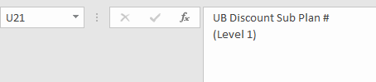

Data shown 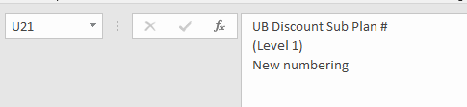

1. Cell X21 and X40021 data issue

Requirement 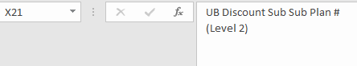

Data shown 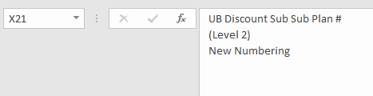

1. Cell AA21 and AA40021 data issue

Requirement 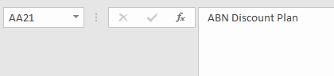

Data shown 

1. Country alphabetical order issue from column IP to column IU

Correct order should be :

Tuvalu

Uganda

Ukraine

United Arab Emirates

United Kingdom

Uruguay

US Minor Outlying Islands (Wake Island)

Uzbekistan

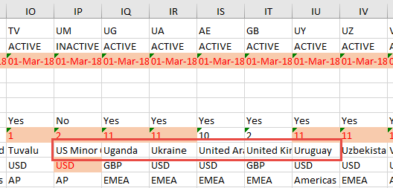

1. Country Cyprus with two currencies not align in the same column of future SOC table and current SOC table.

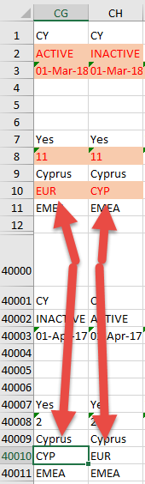

# Left Section Columns

1. This is missing.

Cell AE23 highlighted pink, Right justified - see text in the cell:



1. No blank line before a new Product Grouping
2. There are a total number of 78473 data values mismatch. Please find the detail compare result attached.



# Product Grouping and Billing Elements Order Sequence Issues

Product Groupings are in the correct order sequence but they have following issues.

1. Duplicate POP Diversity product grouping label in both Future SOC table and Current SOC table

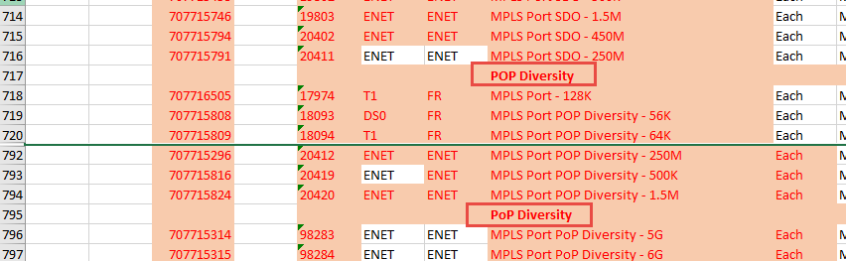

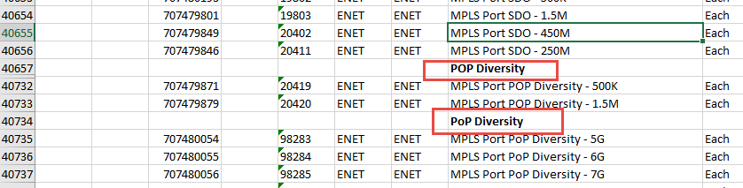

1. There are a total number of 17429 BEIDs not in the right place (sorting sequence) in their own grouping. Analysis in file attached.



1. Number of BEIDs for Future SOC table and Current SOC table are different. BEIDs are not aligned.
2. Missing BEIDs
   1. Total number of BEIDs which are ACTIVE, INACTIVE or ORT in BEID Master = 17588
   2. Total number of BEIDs in IT file = 17156
   3. Total number of BEIDs not found in IT file = 432 (listed as below)

BEID 6060606

BEID 18193

BEID 18194

BEID 18195

BEID 18196

BEID 18197

BEID 18198

BEID 18199

BEID 18200

BEID 18201

BEID 18202

BEID 18203

BEID 18204

BEID 18205

BEID 18206

BEID 18207

BEID 18208

BEID 18209

BEID 18210

BEID 18211

BEID 18212

BEID 18213

BEID 18214

BEID 18215

BEID 18216

BEID 18217

BEID 18218

BEID 18219

BEID 18220

BEID 18221

BEID 18222

BEID 18223

BEID 18224

BEID 18225

BEID 18226

BEID 18227

BEID 18228

BEID 18229

BEID 18230

BEID 18231

BEID 18232

BEID 18233

BEID 18234

BEID 18235

BEID 18236

BEID 18237

BEID 18238

BEID 18239

BEID 18240

BEID 18241

BEID 18242

BEID 18243

BEID 18244

BEID 18245

BEID 18246

BEID 18247

BEID 18248

BEID 18249

BEID 18250

BEID 18251

BEID 18252

BEID 18253

BEID 18254

BEID 18255

BEID 18256

BEID 18257

BEID 18258

BEID 18259

BEID 18260

BEID 18261

BEID 18262

BEID 18263

BEID 18264

BEID 18265

BEID 18266

BEID 18267

BEID 18268

BEID 18269

BEID 18270

BEID 18271

BEID 18272

BEID 18273

BEID 18274

BEID 18275

BEID 18276

BEID 18277

BEID 18278

BEID 18279

BEID 18280

BEID 18281

BEID 18282

BEID 18283

BEID 18284

BEID 18285

BEID 18286

BEID 18287

BEID 18288

BEID 18289

BEID 18290

BEID 18291

BEID 18292

BEID 18293

BEID 18294

BEID 18295

BEID 18296

BEID 18297

BEID 18298

BEID 18299

BEID 18300

BEID 18301

BEID 18302

BEID 18303

BEID 18304

BEID 18305

BEID 18306

BEID 18307

BEID 18308

BEID 18309

BEID 18310

BEID 18311

BEID 18312

BEID 18313

BEID 18314

BEID 18315

BEID 18316

BEID 18317

BEID 18318

BEID 18319

BEID 18320

BEID 18321

BEID 18322

BEID 18323

BEID 18324

BEID 18325

BEID 18326

BEID 18327

BEID 18328

BEID 18329

BEID 18330

BEID 18331

BEID 18332

BEID 18333

BEID 18334

BEID 18335

BEID 18336

BEID 18337

BEID 18338

BEID 18339

BEID 18340

BEID 18341

BEID 18342

BEID 18343

BEID 18344

BEID 18345

BEID 18346

BEID 18347

BEID 18348

BEID 18349

BEID 18350

BEID 18351

BEID 18352

BEID 18353

BEID 18354

BEID 18355

BEID 18356

BEID 18357

BEID 18358

BEID 18359

BEID 18360

BEID 18361

BEID 18362

BEID 18363

BEID 18364

BEID 18365

BEID 18366

BEID 18367

BEID 18368

BEID 18369

BEID 18370

BEID 18371

BEID 18372

BEID 18373

BEID 18374

BEID 18375

BEID 18376

BEID 18377

BEID 18378

BEID 18379

BEID 18380

BEID 18381

BEID 18382

BEID 18383

BEID 18384

BEID 18385

BEID 18386

BEID 18387

BEID 18388

BEID 18389

BEID 18390

BEID 18391

BEID 18392

BEID 18393

BEID 18394

BEID 18395

BEID 18396

BEID 18397

BEID 18398

BEID 18399

BEID 18400

BEID 18401

BEID 18402

BEID 18403

BEID 18404

BEID 18405

BEID 18406

BEID 18407

BEID 18408

BEID 18409

BEID 18410

BEID 18411

BEID 18412

BEID 18413

BEID 18414

BEID 18415

BEID 18416

BEID 18417

BEID 18418

BEID 18419

BEID 18420

BEID 18421

BEID 18422

BEID 18423

BEID 18424

BEID 19672

BEID 19673

BEID 19674

BEID 19675

BEID 19676

BEID 19677

BEID 19678

BEID 19679

BEID 19680

BEID 19681

BEID 19682

BEID 19683

BEID 19684

BEID 19685

BEID 19686

BEID 19687

BEID 19688

BEID 19689

BEID 19690

BEID 19691

BEID 19692

BEID 19693

BEID 19694

BEID 19695

BEID 19696

BEID 19697

BEID 19698

BEID 19699

BEID 19700

BEID 19701

BEID 19702

BEID 19703

BEID 19704

BEID 19705

BEID 19706

BEID 19707

BEID 19708

BEID 19709

BEID 19710

BEID 19711

BEID 19712

BEID 19713

BEID 19714

BEID 19715

BEID 19716

BEID 19717

BEID 19718

BEID 19719

BEID 19720

BEID 19721

BEID 19722

BEID 19723

BEID 19724

BEID 19725

BEID 19726

BEID 19727

BEID 19826

BEID 19827

BEID 19828

BEID 19829

BEID 19830

BEID 19831

BEID 19832

BEID 19833

BEID 198801

BEID 20405

BEID 20406

BEID 20407

BEID 20408

BEID 20414

BEID 20415

BEID 20416

BEID 20417

BEID 21977

BEID 21978

BEID 21979

BEID 21980

BEID 21981

BEID 21982

BEID 21983

BEID 21984

BEID 21985

BEID 21986

BEID 21987

BEID 21988

BEID 21989

BEID 21990

BEID 21991

BEID 21992

BEID 21993

BEID 21994

BEID 21995

BEID 21996

BEID 21997

BEID 21998

BEID 21999

BEID 22000

BEID 22001

BEID 22002

BEID 22003

BEID 22004

BEID 22005

BEID 22006

BEID 22007

BEID 22008

BEID 22009

BEID 22010

BEID 22011

BEID 22012

BEID 22013

BEID 22014

BEID 22015

BEID 22016

BEID 22017

BEID 22018

BEID 22019

BEID 22020

BEID 22021

BEID 22022

BEID 22023

BEID 22024

BEID 22025

BEID 22026

BEID 22027

BEID 22028

BEID 22029

BEID 22030

BEID 22031

BEID 22032

BEID 22033

BEID 22034

BEID 22035

BEID 22036

BEID 22037

BEID 22038

BEID 22039

BEID 22040

BEID 22041

BEID 22042

BEID 22043

BEID 22044

BEID 4545

BEID 90131

BEID 90132

BEID 90133

BEID 90134

BEID 90135

BEID 90136

BEID 90137

BEID 90138

BEID 90139

BEID 90140

BEID 90141

BEID 90142

BEID 90143

BEID 90144

BEID 90145

BEID 90146

BEID 90147

BEID 90148

BEID 90149

BEID 90150

BEID 90151

BEID 90152

BEID 90153

BEID 90154

BEID 90155

BEID 90156

BEID 90157

BEID 90158

BEID 90159

BEID 90160

BEID 90161

BEID 90162

BEID 98298

BEID 98299

BEID 98300

BEID 98301

BEID 98302

BEID 98306

BEID 98307

BEID 98308

BEID 98309

BEID 98310

BEID 98311

BEID 98315

BEID 98316

BEID 98317

BEID 98318

BEID 98319

BEID 98320

BEID 98324

BEID 98325

BEID 98326

BEID 98327

BEID 98328

BEID 98329

BEID 98333

BEID 99922

# SP BEID RATE

Data comparison to be done later